

|  |  |
| --- | --- |
| Report for: | Cabinet |
| Date of Meeting: | 25 May 2023 |
| Subject: | Social Housing Decarbonisation Fund (SHDF) wave 2.1 |
| Key Decision: | Yes - the work will impact a minimum of two wards across Harrow and requires significant expenditure to enable the delivery of a 2-year contract valued to £5.1m, of which grant funding has been approved by DESNZ to £2.147m. |
| Responsible Officer: | Dipti Patel - Corporate Director of Place  David McNulty- Director of Housing |
| Portfolio Holders: | Councillor Mina Parmar - Portfolio Holder for Housing |
| Exempt: | No except for appendices 1,2,3 and 5 which are exempt by virtue of paragraph 3 of Schedule 12A Local Government Act 1972).  as they contain information relating to the financial or business affairs of any particular person (including the authority holding that  information). |
| Decision subject to Call-in: | Yes |
| Wards affected: | All |
| Enclosures: | Appendix 1: DESNZ – Harrow Baseline forecast parts 1 & 2 (EXEMPT)  Appendix 2: DESNZ – Harrow Project Plan (EXEMPT)  Appendix 3: Grant Funding Agreement (EXEMPT)  Appendix 4: Grant Offer Letter  Appendix 5: Expression of Interest (EOI) (EXEMPT) |

|  |
| --- |
| Section 1 – Summary and Recommendations |
| This report sets out delivery of a landmark central government grant funded scheme for housing decarbonisation. The Social Housing Decarbonisation Fund (SHDF) wave 2.1 is a 2-year programme with a strict reporting, contractual and milestone delivery framework set by the *Department for Energy Security and Net Zero* (DESNZ).  Following the London Borough of Harrow’s successful grant bid for 100% of applied funding, Harrow has been awarded with the highest grant relative to stock size in London – at £2.147m contributing to a contract circa £5.1m of which £2.93m will be co-funding by Harrow to deliver energy efficiency works across over 226 homes. At the time of writing this cabinet report, in principle financial commitment has been provided for the full budget requirement subject to our internal governance process being followed with cabinet approval. The required proof of co-funding has been submitted to DESNZ by our Chief Finance Officer (CFO).  **Recommendations:**  Cabinet is requested to:   * 1. Approve the DESNZ 2-year spend profile as set out in appendix 2, which has been submitted to central government together with the Grant Funding Agreement. This spend profile outlines how the council will deliver the SHDF programme to March 2025 across a minimum of 226 homes, incorporating the required approval request to add the £2.147m additional Grant received into the HRA capital programme, specified by DESNZ as £917k in 2023/24 and £1. 230m in 2024/25.   2. Approve the DESNZ specified procurement requirement for the Harrow SHDF programme which incorporates the required delegated authority for the DESNZ mandatory process approval and identification of the council’s delivery partner, completing SHDF milestone 1 of the programme[1]*. As set out in the procurement plan, through direct appointment on the specialist Fusion 21 decarbonisation framework: ensuring value for money and a fair and transparent process by selecting the highest-ranked contractor on LOT 1 of the pre-evaluated framework.   3. Delegate Authority to Corporate Director of Place following consultation with the Portfolio Holder for Housing and Portfolio Holder for Finance and Human Resources and the Director of Finance to finalise the award of contract.  Reason: (for recommendations) The delivery of the SHDF programme will enable the Council to:   * Meet critical Harrow climate emergency directives and central government energy efficiency targets contributing to the roadmap to Net Zero, by achieving a minimum EPC rating of C using a fabric-first approach across all homes on the SHDF wave 2.1 programme. * Meet all statutory delivery milestones set by DESNZ for the specified delivery window for implementation, as set out in Table 9 of the bid. * Meet the spend profile requirement as set out by DESNZ – in ANNEX 6 of the Grant Funding Agreement (GFA) which stipulates 42.7% of the Grant Funding it received in the 2023-24 Financial Year and 57.3% in 2024/25. Crucially, this can only be achieved by the approved procurement plan to identify the Harrow delivery partner in the month of May 2023. This will allow for contract proceedings in June, abiding by timescales for delivery which have been set by DESNZ with full programme completion on-site required by March 2025. This process follows the comprehensive Harrow KPI submission to DESNZ in April 2023, allowing for crucial May 2023 cabinet approval. |

## Section 2 – SHDF 2.1 programme

### Options considered

**(a) Do Nothing:** The London Borough of Harrow will not be able to meet the central government set reporting framework, and will therefore lose grant funding and terminate proceedings with the SHDF wave 2.1 programme.

**(b) Approve parts 1.1, and 1.2 in section 1 of this cabinet report:** This is the recommended option as it will enable the London Borough of Harrow to deliver the landmark project, taking full advantage of the awarded grant funding to deliver a best value programme together with the specified SHDF delivery partner as set out by DESNZ.

* 1. **Background**
  2. **Fossil Fuels**

Burning coal, gas and oil (together known as fossil fuels) is increasing the concentration of carbon dioxide in the earth’s atmosphere, causing a global temperature rise and significant disruption to our climate. The UK government has set a target for social housing providers to attain the minimum rating of Energy Performance Certificate (EPC) C for rented properties by 2035 (2030 for ‘fuel poor’ households). This is an important milestone towards the longer term, and much more ambitious and challenging aspiration, to make all homes ‘net-zero-carbon’ by 2050

* 1. **Benchmark energy performance**

According to the 2019 English House Condition Survey, the average Standard Assessment Procedure (SAP) rating of the social housing stock in England and Wales is 68.4, with 44% of dwellings having an energy efficiency rating below EPC C (SAP 69). The *Pathways* report summary for the London Borough of Harrow shows the following baseline figures in the table below:

**Chart 1 - Harrow - Pathways**

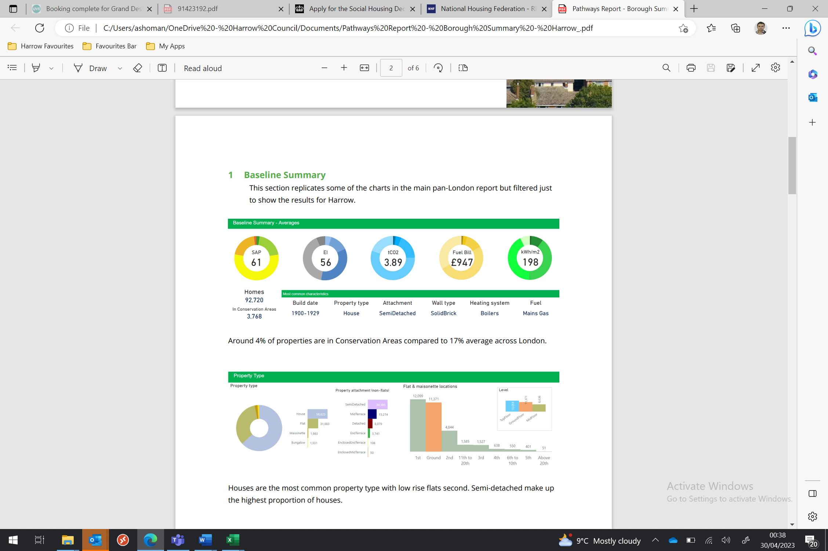

* 1. **Key Decision background**

Following the Harrow Climate Emergency Declaration previously referred to Cabinet in September 2019, a key decision related to the scale and pace of transformation was identified across both the organisation and the borough as a whole in order to address the 2030 target date for carbon neutrality. The SHDF wave 2.1 programme provides a significant opportunity to address this requirement across our housing stock commencing in 2023/24.

* 1. **Stock Summary** Harrow Council owns circa 4,800 homes, which are managed through its Housing Revenue Account (HRA).[2] This equates to approximately 5% of total stock in the borough.[3] The Council also manages circa 1,200 leasehold properties (largely former Council owned flats sold under the Right to Buy), nearly 800 garages and 11 community centres.
  2. **Social Housing Decarbonisation Fund**

The Social Housing Decarbonisation Fund (SHDF) will upgrade low energy efficient social housing stock currently below Energy Performance Certificate (EPC) C up to that standard. It will support the installation of energy performance measures in social homes in England, and help:

* deliver warm, energy efficient homes
* reduce carbon emissions
* tackle fuel poverty
* support green jobs
* develop the retrofit sector
* improve the comfort, health and well-being of social housing tenants

SHDF is a £3.8bn 2019 Conservative manifesto commitment over a 10-year period to improve the energy performance of social rented homes, on the pathway to Net Zero 2050.

The Wave 2.1 competition will allocate up to £800 million of funding to support the installation of energy performance measures in social homes in England.

The SHDF Wave 2.1 competition closed to applications on 18 November 2022.

DESNZ makes the Grant to the Grant Recipient (London Borough of Harrow) for the provision of SHDF Wave 2.1, on the basis of the Grant Recipient’s successful grant application.

1.6 **Application Process**

The London Borough of Harrow completed the prerequisite PAS2035 energy surveys and the full SHDF wave 2.1 application process in November 2022. The included board sign-off and in principal financial approval in November as per appendix K of the required application submission stipulated by DESNZ.

1.7 **Ambition | Strategic approach**

As part of the council’s SHDF wave 2.1 application, the Council set out

an ambitious retrofit plan. This included the planned upgrade of 100% of its poorly performing BISF archetype non-traditional housing stock of the approved decarbonisation roadmap. This will see the remainder of 97 BISF properties whole-house retrofitted with fabric first measures and Solar PV, to achieve EPC Band C and above over the next 2 financial years of delivery. The programme includes Capital funding for windows, roofs, doors and ventilation to be delivered in parallel with Bid measures.

* 1. **Outcome**

The result of Harrow’s successful strategy is the largest SHDF wave

grant allocation in London relative to stock size, which represents a landmark achievement for a delivery programme across housing decarbonisation. This is testament to a vision and strategy for implementation which has already seen success with two previous housing decarbonisation grants in 2022/24 and 2023/24 across both LAD2 and LAD3 HUG1 with our current GLA contract.

**2.0 Delivering our objectives**

2.1 Key decision making and implementation of SHDF wave 2.1 will enable Harrow to meet energy performance targets at both local and national level.

2.2 **Approved Grant Measures**

Harrow’s SHDF implementation strategy sets out a clear delivery pathway submitted to DESNZ, with a grant fund bid to support delivery of the following energy efficiency measures:

**Table 1 – measures**

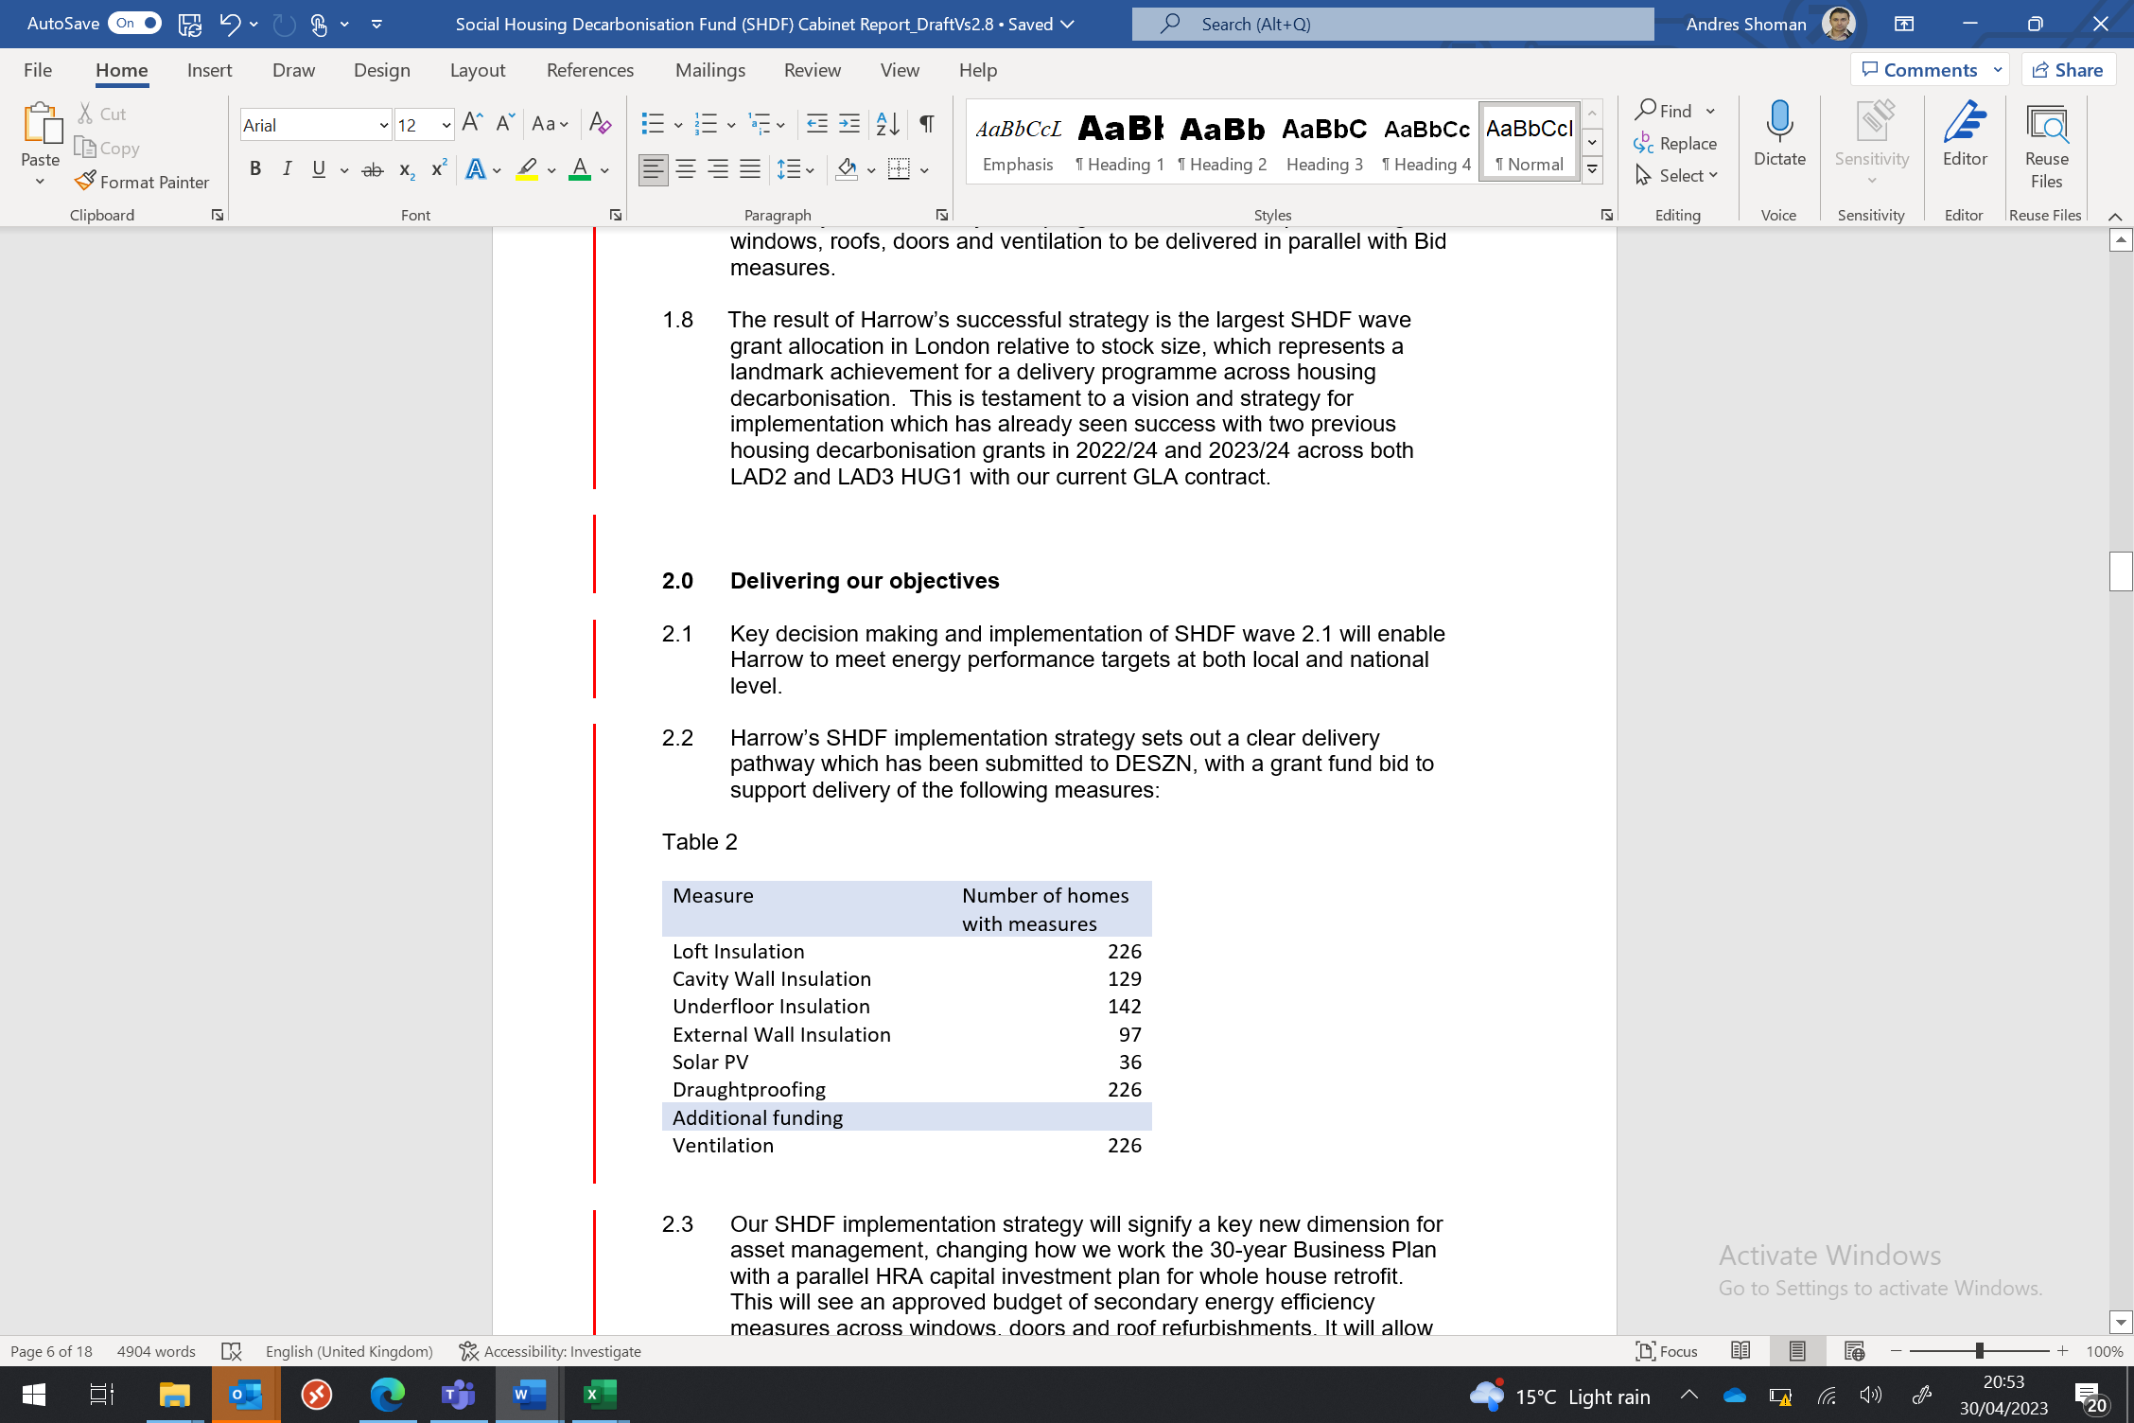Secondary measures: Windows, Doors, Roofs up to 226

2.3 **Changing the way we work**

Our SHDF implementation strategy provides a new dimension for asset management, changing the way we work and how we develop the 30-year Business Plan. We achieve this with a parallel HRA capital investment plan for whole-house retrofit. This will see an approved budget of secondary energy efficiency measures across windows, doors and roof refurbishments. This strategy will allow us to really target where investment is needed, supporting value for money and resident satisfaction.

2.4 **PAS2035 (Energy Assessment, Design coordination) Process**

A crucial aspect of SHDF programme implementation is the approved PAS2035 process which commenced as part of the DESNZ submitted profile for Ancillary costs. This follows the key DESNZ requirement for completing PAS2035 surveys across the 226 homes identified, further to the assessments which were approved as part of the November 2022 bid. Following completion of full internal governance processes in 2022, the Council commissioned Pellings LLP to undertake the initial retrofit coordinator role ahead of appointment of our main delivery partner as per paragraphs 1.2 and 1.3 (page 2) of this report.

2.5 **KPI submission to central government**

To ensure successful deliver of the SHDF wave 2.1 programme, the following documents and KPIs have already been submitted to DESNZ:

* Full checklist – including Baseline projections for the entire 2-year programme (Appendix 1 parts 1 and 2)
* Fraud Risk Assessment
* Programme risk assessment
* Grant Funding Agreement – for co-signing
* Grant Offer Letter – for co-signing
* Full bank details provision – approved and signed by CFO
* Full project plan (Appendix 2)
* Oracle financial systems form completed
* Proof of funding

*2.6* **Submission to Fusion 21 Framework**

*Further to point 2.5* The following documents have been submitted for LOT1 Fusion21 direct appointment briefing, EOI and evaluation

* Project brief
* Full property listing for programme
* Number of measures approved in bid (Table 1 part 2.2)

2.7 **Internal review**

The following documents have been reviewed by the procurement business partner in April 2023:

* Full specifications for all energy efficiency measures proposed
* Full contractor EOI responses
* Fusion 21-member framework evaluation with ranked contractors
* Approved project plan

2.7 **Best practice**

We will seek to adopt a comprehensive set of new best practice across housing decarbonisation, leading with national standards for *implementation, innovation, and delivery*. A testament to this work is the April 2023 Harrow case study which represents the first transparent solar glass application in the UK for social housing. The concept has been showcased at the Grand Designs LIVE 2023 exhibition (London Excel) in partnership with Polysolar technology.

2.8 **Fuel Poverty**

We are actively dealing with Fuel poverty through the SHDF programme which will reduce bills as a result of measure implementation. This follows a recent influx fuel poverty referral which we are addressing as part of our wider housing decarbonisation programme.

* 1. **Summary objectives of whole-house retrofit**

The SHDF programme will be addressing key performance objectives across the following areas:

* Damp & Mould: Through fabric first intervention, improved insulation and smart ventilation across homes, minimising Health & Safety risk.
* Comfort and wellbeing: Warmer and better insulated homes which provide enhanced living environments with enhanced ambient temperature management across winter and summer extremes.
* Fuel Poverty – tangible bill reduction following programme of energy efficiency measures.
* Carbon reduction – through whole house retrofit
* Renewable energy integration – solar PV installation across multiple homes
* Environmental control – through sensors which can remotely monitor humidity, temperature and cardon dioxide emissions, informing of multiple indicators for decarbonisation

2.10 **Resident engagement summary**

Our Resident Engagement Strategy for SHDF delivery provides an active approach to management with a project lead role that maintains regular contract with our key stakeholders – our residents. This includes a focus on the often-neglected management of tariffs to achieve practical outcomes with addressing fuel poverty. The ambition for the borough is for *“great customer experiences and community outcomes”.* It is important that we layer in the customer experience throughout the delivery of the SHDF programme.

**3.0 Measuring Performance** – include relevant KPI’s and performance against them

3.1 **SHDF Milestones**

Performance management is a critical aspect of the SHDF programme and follows a delivery framework with KPI’s set by central government. In the first instance, these consist of 9 base milestones as per table 9 of the bid:

**Table 2 - Milestones**

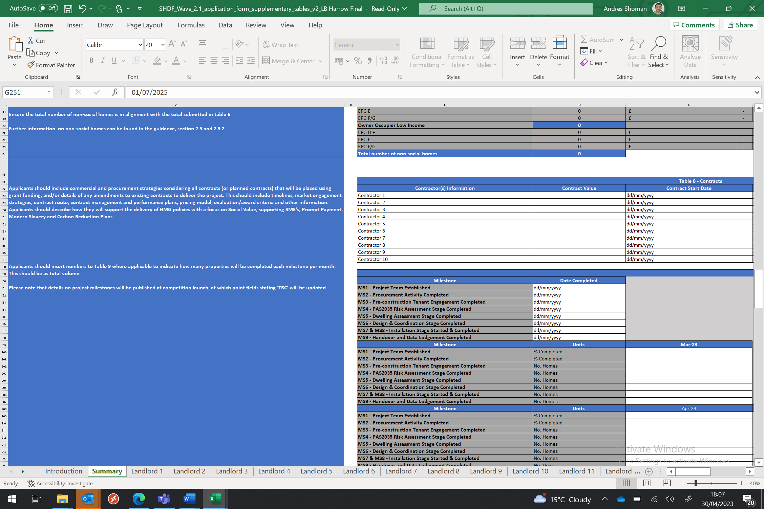

3.2 **Statutory spend profile**

DESNZ have profiled an agreed outputs profile as stipulated in ANNEX 6 of the Grant Funding Agreement (GLA), as follows:

*The Grant Recipient is required to achieve the following milestones and performance measures in connection with the Grant:*

*Agreed Outputs 1.*

* *Grant Recipient is to have spent approximately 42.7% of the Grant Funding it received in the 2023-24 Financial Year by the end of that Financial Year on the Funded Activities. 2.*
* *Grant Recipient is to have spent approximately 57.3% of the Grant Funding it received in the 2024-25 Financial Year by the end of that Financial Year on the Funded Activities.*

3.3 **Energy efficiency measure performance**

A crucial aspect of the funding requirement. This specifically relates to Energy Performance Certificate (EPC) to achieve EPC C with all homes with a space heat demand below 90 kWh/m2/yr, where possible and cost effective.

All modelling has been undertaken in Reduce Data Standard Assessment Procedure (RdSAP), using the Elmhurst Platform.

3.4 **Stock upgrade – Scope**

The SHDF programme will upgrade a significant amount of the social housing stock, delivering warm, energy-efficient homes, reducing carbon emissions and fuel bills, tackling fuel poverty, and supporting green jobs. Performance across each element is quantifiable based on the SHDF reporting mechanism. The PAS2035 process is also a key KPI in this area is it stipulates the calculated requirement for achieving the energy performance objective per dwelling, culminating in lodgement.

3.5 **Levels of Decency**

A key aspect which strengthened the successful London Borough of Harrow grant bid was the HRA commitment to run a parallel planned investment programmes for windows, doors and roofs refurbishment. Apart from the clear benefits which include:

* Aiding whole-house retrofit with the application of secondary measures such as with window refurbishment carried out together with SHDF funded External Wall Insultation (EWI).
* Minimising resident disturbance and ensuring a best value by packaging works with a more holistic approach retrofit.

A key deliverable will be the resulting impact on *Decency (Decent Homes Standard reporting)*, with works that address both low energy efficient **and** non-decent dwellings through whole-house retrofit.

3.6 **Health & Safety benefits**

Damp and Mould - The SHDF programme will directly address the causes of damp and mould by effective appraisal, and an approved grant funded work plan that includes:

* Insulation improvements (Cavity | loft | underfloor | External Wall Insulation)
* Ventilation upgrades including smart ventilation (Combating damp and mould and improving air quality with a positive impact to occupant’s health, filtering large pollen particles and reducing the impact of household products that emit volatile organic compounds (VOCS).
* Draughtproofing (to maximise energy efficiency)
* Environmental sensors with remote monitoring (of damp, humidity, temperature, carbon dioxide)

3.7 **Project Plan | baseline**

The specific targets and milestones of DESNZ programme reporting which must abide with the full project plan and submitted baseline (Appendix 1 parts 1 and 2)

**4.0 Environmental Issues for project delivery**

4.1 The SHDF programme directly addresses environmental issues in a more comprehensive and targeted manner than any former HRA housing capital programme. The grant funded baseline measures and programme will address all of the following without exception:

* **Tackle fuel poverty** by increasing low-income household’s energy efficiency rating and therefore reducing their energy bills.
* **Support clean growth** and ensure homes are thermally comfortable, efficient, and well-adapted to climate change.
* **Support economic resilience and a green recovery** in response to the economic impacts of Covid-19, creating thousands of jobs; and
* **Learn from the delivery experience** to inform the development and design of further energy efficiency and heat schemes.
* **Reduce carbon emissions** from homes within our boroughs, directly contributing to addressing the declared climate emergency.

4.2 **Fundamental environmental requirements**

For the measures proposed, environmental requirements are clearly outlined in part 17 of the *Grant Funding Agreement* submitted to DESNZ:

*The Grant Recipient shall perform the Funded Activities in accordance with the Authority’s environmental policy, which is to conserve energy, water, wood, paper, and other resources, reduce waste and phase out the use of ozone depleting substances and minimise the release of greenhouse gases, volatile organic compounds and other substances damaging to health and the environment.*

*The Grant Recipient shall pay due regard to the use of recycled products, so long as they are not detrimental to the provision of the Funded Activities or the environment, to include the use of all packaging, which should be capable of recovery for re-use or recycling.*

*The Grant Recipient shall take all possible precautions to ensure that any equipment and materials used in the provision of the Funded Activities do not contain chlorofluorocarbons, halons, or any other damaging substances, unless unavoidable, in which case the Authority shall be notified in advance of their use. The Grant Recipient shall endeavour to reduce fuel emissions wherever possible.*

**5.0 Data Protection Implications**

#### 5.1 Processing of personal data

#### All personal data processed in connection with the SHDF programme Strategy, and any related procurement will be carried out in full compliance with data protection laws including the Data Protection Act 2018 and the UK General Data Protection Regulation.

5.2 **Data Sharing Agreement**

Please refer to the signed Data Sharing Agreement as submitted to DESNZ.

### 6.0 Risk Management Implications

6.1 Risks included on corporate or directorate risk register? **Yes**

Separate risk-register in place? **Yes**

The relevant risks contained in the register are attached/summarised below. **Yes**

|  |  |  |
| --- | --- | --- |
| **Risk Description** | **Mitigations** | **RAG Status** |
| If the recommendations are not accepted the Council will be unable to receive grant funding from the DESNZ for the SHDF wave 2.1 programme in the Borough | * The report sets out a process by which this risk can be mitigated | **GREEN** |
| The SHDF Wave 2.1 implementation strategy fails to effectively achieve its objectives and/or within the envisaged timescale for the Programme | * Project Board in place to monitor the strategy * Approved government project plan and project baseline in place * Milestones have been set for the strategy by both the Council and the government and these will be closely monitored | **GREEN** |
| The SHDF Wave 2.1 Programme runs significantly over budget | * Work proactively with the finance business partner to ensure timeline monthly audit reporting on a measure-by-measure basis both internally and externally to the government * Forecasts and actuals allow for contingency planning. Planning is engaged where required such as for External Wall Insulation (EWI) * Allowances for possible supply chain shortages and material costs have been factored into the budget * Learning curve benefits have been obtained via undertaking a previous energy efficiency Programme (ECO1-2) and this will help us control the budget | **AMBER** |
| The approximate 40/60 required spend profile between the Council and the government respectively is not met and is significantly off-target | * Works will not be instructed if an overspend is identified/predicted as being off-target, e.g. changes in market conditions * Underspends can in exceptional circumstances be negotiated with the government to enable these to be redirected into the project | **AMBER** |
| The resident engagement strategy is unsuccessful leading to resident dissatisfaction and opposition to the Programme | * Works will be coordinated in a manner which minimizes disturbance on a resident-by-resident basis * Vulnerable residents are prioritised and we will work closely with them and there is a contingency plan in place for this * This area of resident concern and vulnerability is specifically overseen by the Project Board * Resident feedback is closely monitored | **GREEN** |
| Fraud occurs in delivery of the SHDF programme | * A programme risk register (including the risk of fraud) has been submitted and reviewed by central government and will be regularly reviewed and updated during the Programme * Members of the Project Team have received fraud awareness training * A specific fraud risk register is also in place and submitted and reviewed by central government and this will also be regularly reviewed and updated for the risk of fraud during the Programme | **AMBER** |
| SHDF programme fails to adhere to DESNZ processes and risks loss of grant allocation | * Baseline project forecast and project plan are monitored regularly on a monthly basis to oversee adherence * The Fusion21 agreement also ensures adherence to the agreed project milestones with the nominated delivery partner * Supply chain and material resources are fully accounted for by the framework evaluation process on a contractor-by-contractor basis | **AMBER** |
| VFM not achieved for programme through delivery partner. | * Procurement selects top ranked contractor from pre-evaluation framework * Assessment process ensures VFM via the following: - * Delivery partner must adhere to the government submitted spend profile * Spend profile forms part of the contractual agreement with the Partner * Spend profile is stipulated in the grant funding agreement which must be adhered to and is non-negotiable | **AMBER** |
| Failure to Meet statutory requirements and KPIs sent by DESNZ | * The Project Lead role ensures a fully documented timeline and central government checklist, with feedback showing compliance access every set KPI. * DESNZ facilitates monthly review and audit to ensure completion of all 9 milestones. | **AMBER** |
| Failure to improve energy efficiency of homes on programme | * The PAS2035 process regulates the action to be taken on a dwelling-by-dwelling basis. * Contractors of the Fusion21 framework are Trustmark Accredited. * Energy Lodgement process ensures outcomes. | **AMBER** |
| Failure to ensure effective investment in our assets for whole-house retrofit | * Procurement must agree with the set and agreed central government grant funded measures, as documented in Harrow’s successful grant bid. * The delivery partner must abide to set criteria for pricing that is in agreement with the central government submitted baseline forecast. * Whole-house retrofit must be conducted to the highest standards following the specifications, “validated” by way of SAP EPC scoring for before and after completion | **AMBER** |

### 7.0 Procurement Implications

7.1 **Consultation overview**

This report has been compiled following consultation with the procurement business partner, outlining recommendations to ensure timely implementation of the central government grant funded SHDF programme.

7.2 **Adherence to central government process**

Procurement options must support the specific central government targets and contractual (Grant Funding Agreement) obligations for programme delivery across 2023/24 to 2024/25. This specifically relates to the framework imposed by central government relating to:

* monthly audit and monitoring
* grant drawdown process
* delivery partner milestones which must abide by baseline forecast submitted to DESNZ
* Implementation plan to baseline + agreed delivery milestones
* Agreed spending requirement and profile for the specific measures identified in table 6.

**Negotiation**

The project attributes in part 7.2 differentiate the SHDF programme from more traditional procurement routes for projects which are not subject to external governmental audit. The *Grant Funding Agreement (GFA)* has provided a non-negotiable stance as follows, stipulated by DESNZ:

*The GFA and associated documents have undergone a rigorous approval process by our legal and commercial teams. In addition, a draft copy of the GFA was uploaded to our competition web page in August 2022, giving applicants the ability to provide suggestions on content which have already been considered.*

7.3 **Procurement through the specialist Fusion 21 decarbonisation framework**

The Framework was subject to an ‘Open’ procurement procedure in accordance with the Public Contracts Regulations 2015 and Public Contracts (Scotland) Regulations 2015.

Rigorous assessment of supplier capability and ability to performance the scope of services was undertaken, key selection criteria included:

* Business and professional standing
* Health, Safety and Wellbeing
* Financial capability
* Experience of delivery
* Past performance

The award criteria for successful suppliers was based on an evaluation model of technical and commercial evidence.

**Table 4 showing Technical Assessment and Commercial Assessment**

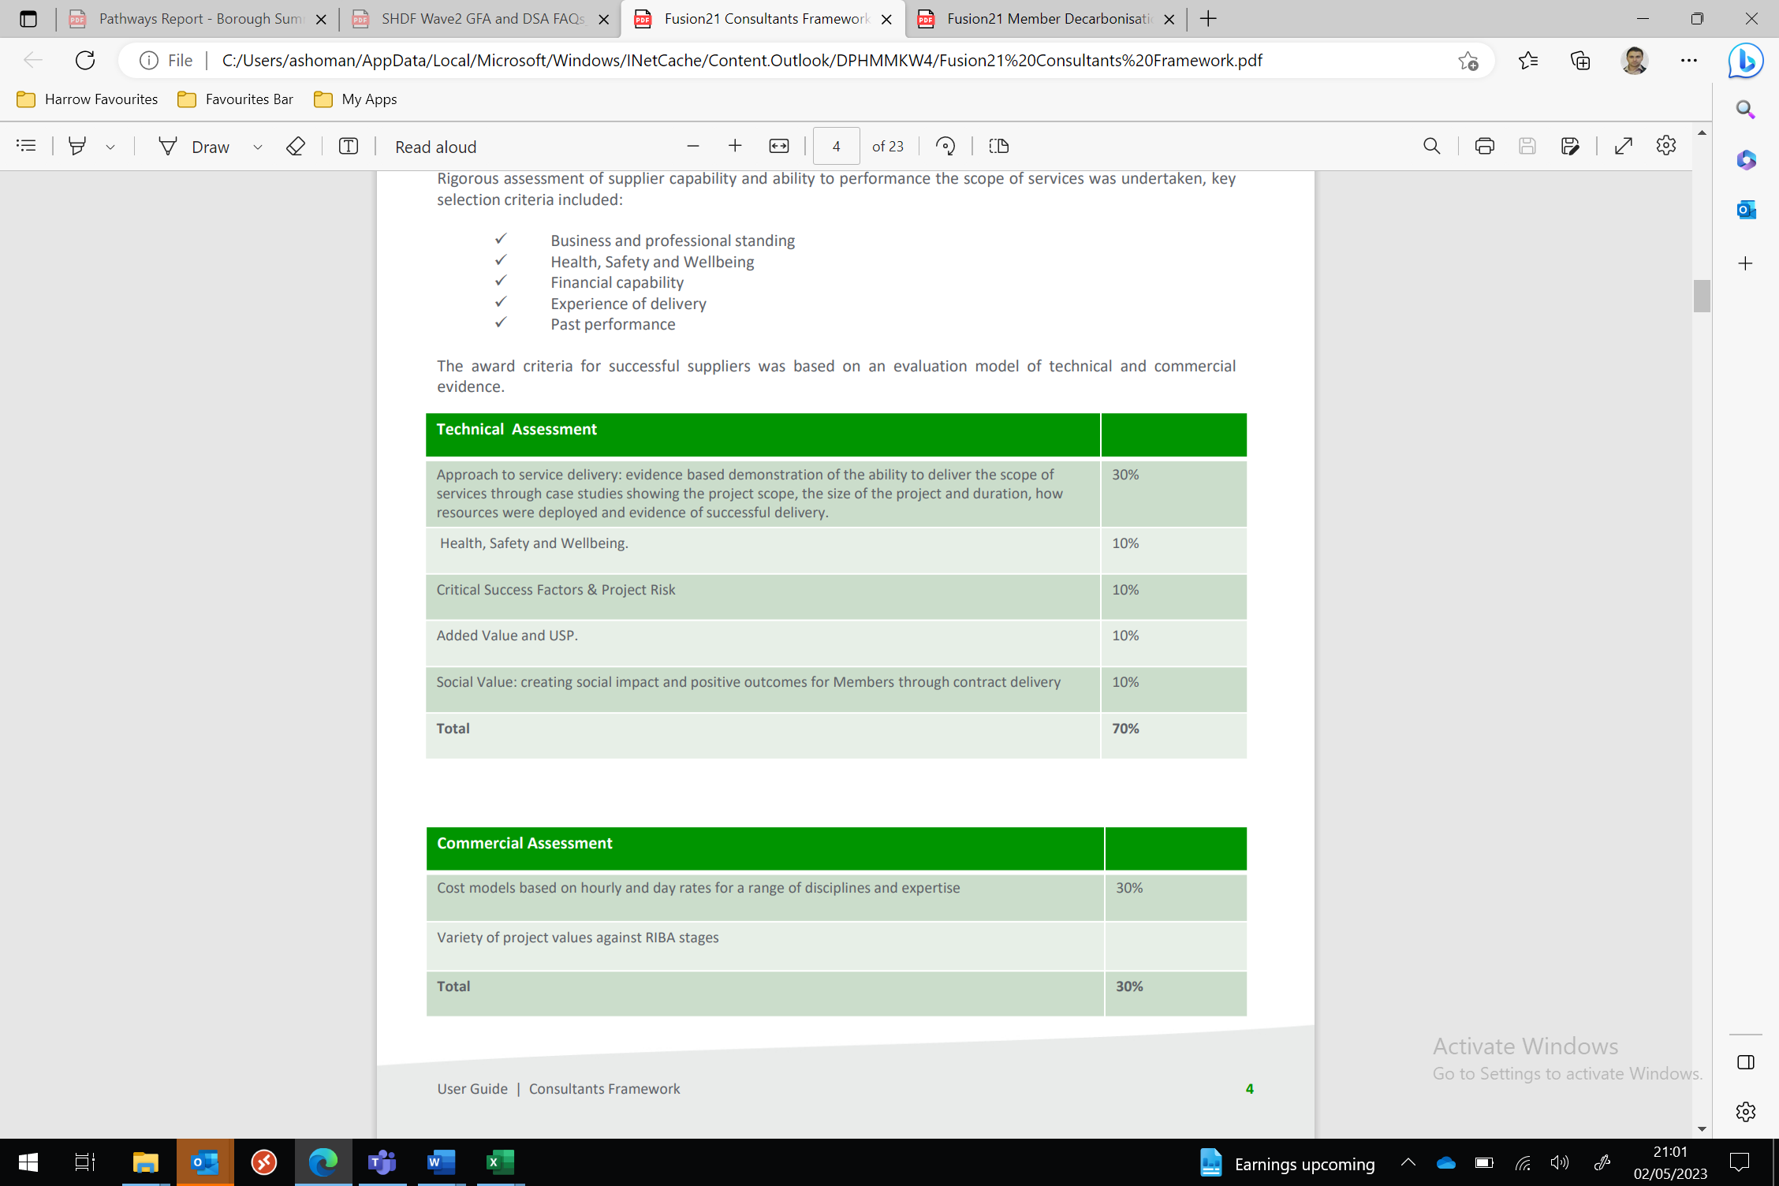

7.4 **Intended Works | Delivery Partner Accreditations**

Works approach based upon ‘whole house’ retrofit measures to PAS2035:2019 standards to domestic dwellings and any other property and related assets owned, rented, leased by any of the Contracting Authorities who may use this framework, or on property and related assets in which any of the Contracting Authorities may have an interest at the time or prospectively.

Intended works cover, but are not limited to:

* Whole house retrofit
* Fabric measures
* Renewable heating technologies
* Solar photovoltaic and battery storage systems
* Improvement works

Supplier Accreditations and Standards

* PAS2035:2019 Standards
* PAS2030:2019 Accredited supply chain
* Trustmark registered supply chain
* Microgeneration certification scheme (MCS)
* Gas Safe
* Electrical safety scheme

7.4 **The recommended procurement route**

Identified for the fulfilment of DESNZ KPI’s was direct appointment on LOT1. Our work has been supported by the procurement business partner and the Fusion 21 Framework Manager (Construction and Decarbonisation).

7.5 **Process Summary | Value for money**

A competitive and best-value process has been carried out through a combination of Expression of Interest and supporting evaluation across a scored, ranked and evaluated 21-strong contractor LOT.

7.6 **Selection**

A secondary evaluation phase ensuring a fair and transparent selection process has been actioned for the 7 contractors who have expressed interest in Table 5 below (commercial sensitive)

This phase incorporated further assurance regarding adherence to the DESNZ submitted baseline forecast, specifically relating to:

1. Available resource to contract-manage HRA capital windows and doors in parallel with SHDF funded measures
2. Adherence to time restraints and the DESNZ defined reporting framework
3. Mobilisation resource provision from 4, 6 or 8 weeks
4. Principal contacts identified if not on initial submission

7.7 **Delivery Partner**

We have adhered by the framework evaluation process with set responses required by all contractors who have expressed interest and submitted the initial evaluation questions. Following the secondary phase review outlined in part 7.6, the requirement to abide by the framework selection process is be based on the highest-ranking contractor being selected from the Fusion 21 LOT1. Formal acceptance will be subject to the required pre-contract agreement to pricing schedules, DESNZ baseline, agreed milestones, prelims and fees. We will follow the Fusion 21 standard JCT route (type TBC) for our nominated delivery partner (preferred bidder) with provision of contractual review with agreed clauses and appendices ahead of contract agreement and sealing.

7.8 **Completion**

Contract sealing is scheduled for June to July 2023, in line with the agreed project timescales submitted to central government as well as the baseline forecast for works to commence on-site in August 2023.

### 8.0 Legal Implications

8.1 **Contractual obligations**

The SHDF programme has stipulated a robust contractual process for delivery across the country. The London Borough of Harrow has completed the prerequisite review and submission of the Grant Funding Agreement, Grant Offer Letter and Data Sharing Agreement. This process was aided by the principal lawyer who provided the necessary advice and guidance for submission ahead of signature approval by the Director of Housing and Director of Finance.

As stipulated by central government (DESNZ), we have completed the required agreement and returned as per the timeframes stipulated for April 2023.

*Is there an opportunity to change the content of the GFA?*

*The GFA and associated documents have undergone a rigorous approval process by our legal and commercial teams. In addition, a draft copy of the GFA was uploaded to our competition web page in August 2022, giving applicants the ability to provide suggestions on content which have already been considered. As a result, it is not possible to make amendments and the GFA can only be shared in a PDF format. If this presents an issue and the signing process is difficult to achieve within the timeline specified, please contact us. The GFA and accompanying guidance documents will clearly signpost via highlighted fields where BEIS requires the input of information from you.*

8.2 **Statutory Powers**

The council has various statutory powers and duties in relation to the development, provision, and maintenance of housing and related matters, including pursuant to:

8.1.1 Housing Act 1985

8.1.2 Housing Act 1996

8.1.3 Housing Act 2004

8.1.4 Housing and Regeneration Act 2008

8.1.5 The Landlord and Tenant Act 1985 (as amended)

8.1.6 The Town & Country Planning Act 1990

8.1.7 The General Power of Competence under the Localism Act 2011

8.1.8 Section 111(1) of the Local Government Act 1972 which gives a local authority the power to do anything (whether or not involving the expenditure, borrowing or lending of money or the acquisition or disposal of any property or rights) which is calculated to facilitate, or is conducive or incidental to, the discharge of any of their functions.

8.3 **Compliance summary**

All procurement relating to the implementation of the SHDF programme must comply with The Public Contracts Regulations 2015 and the council’s Contract Procedure Rules.

8.4 **Contract schedule**

We plan to engage with our nominated legal representative in June to July 2023 in readiness of contract sealing with our nominated delivery partner (preferred bidder). This schedule will ensure adherence to the submitted central government baseline forecast.

### 9.0 Financial Implications

9.1 **Proof of funding KPI**

A key requirement of SHDF programme grant approval *is proof of funding*. The Chief Finance Officer (CFO) has validated the proof of funding requirement to DESNZ in April 2023, confirming the total amount of co-funding agreed in principle as stipulated in table 15 of our bid to a value of £2.93m, ensuring SHDF wave 2.1 delivery across the 2023/24 and 2024/25 financial years.

This funding is the Council’s contribution (co-funding) in addition to the agreed grant allocation of £2.147m provided by DESNZ.

To support the project and its partners, the London Borough of Harrow has an approved housing decarbonisation budget allocation across the three years of the current MTFS. The full co-funding requirement (£2.93m) is derived from this budget. The project will be fully supported by our Finance Business Partner working alongside the Project Lead: Strategy & Programme who heads the SHDF project team, is the budget holder for housing decarbonisation and is responsible for allocation of projects.

In conclusion, the London Borough of Harrow is fully committed to SHDF wave 2.1 programme delivery, co-funding 100% of the agreed amount stipulated above, subject to cabinet approval.

9.2 **Budget Approval**

The Housing decarbonisation budget has been approved for two predominant grant funded schemes and four additional Harrow funded schemes:

1) the GLA LAD3 HUG1

2) SHDF wave 2.1 which this report is concerned with

3) non-grant schemes which have budget approval

The below table provides the summary of the current approved housing decarbonisation schemes including SHDF wave 2.1

**Table 6 – Approved budget**



9.3 The 5-year HRA capital programme was set as part of the Housing Revenue Account Budget (HRA) 2023-24 and Medium-Term Financial Strategy (MTFS) 2024-25 to 2025-26; approved by Cabinet in February 2023.At this time, the SHDF bid grant level was unknown. The HRA cabinet report included an allocation within the HRA capital programme to take advantage of Government grant funding opportunities and match fund Retrofit for carbon reduction measures, set at £1m per annum for years 2023-24 to 2026-27 then £3.0m in 2027-28, at a total investment of £7m.

9.4 This report requests the addition of the £2.147m SHDF grant (£917k in 2023/24 and £1.230m in 2024/25) into the HRA capital programme, and confirms the supporting £2.926m to match fund the above allocation is already available within the current approved capital programme. This will result in total resources of £5.073m available to fund the SHDF scheme over the 2-year period to march 2025.

9.5 The grant conditions stipulate that approximately 40% of total resources will be required to be spent in 2023/24 and 60% in 2024/25 with no carry forward of unspent allocations into future years. The service is currently reviewing the delivery profile to ensure maximum use of the grant funding is achieved.

9.6 The service will monitor this scheme closely and report progress on the scheme through the councils’ normal budget monitoring process.

9.7 There is no impact on the General fund as a result of this addition to the HRA capital programme.

### 10.0 Equalities Implications / Public Sector Equality Duty

10.1 **Continuity**

The SHDF wave 2.1 programme, including the identification of the Harrow delivery partner will align with existing policies and strategies maintaining the current level of equality in service provision. Contract specifications will be very clear on the equalities related duties on contractors, given the wide range of needs of our customers.

10.3 **Social Value | Fuel Poverty | Vulnerable residents**

A critical and unique factor of the SHDF programme is the resulting social value benefits that target households which are experiencing fuel poverty. The consultation phase accounts for the needs of all resident groups, including more vulnerable groups through the provision of:

* Tariff Management advice
* Measures which directly impact a reduction in bills
* Improved lifestyle management across resident groupings, addressed through improve ventilation and environmental sensors forming part of the specification of works
* The provision of warmer, comfortable and more energy efficiency living spaces

10.3 **Assessment**

An initial Equality Impact Assessment has been prepared specific to the SHDF programme. All opportunities to address diversity-particularly vulnerability for all tenants has been addressed through the provision of energy efficiency measures and specifications that ensure residents receive the same service regardless of but taking into account specific needs. The preferred bidder (Harrow delivery partner) will be tasked with the delivery of central government agreed measures which focus on whole-house retrofit across a diverse breakdown of residents.

### 11.0 Council Priorities

The SHDF wave 2.1 programme will ensure all Council priorities are met by delivering an approach that 1. Puts residents first 2. Supports a clean and safe Borough 3. Facilitates support for those most in need.

This will be achieved with the following:

11.1 **Ensuring compliance and mitigating health and safety risk**

As highlighted in part 3.6, this is achieved through the PAS2035 coordinator role which will ensure a package of energy efficiency measures that create safer, warmer, and more comfortable living spaces. Digital Environmental sensors will ensure monitoring post-works.

11.2 **Maintaining decency and improving infrastructure**

Residents will benefit from whole-house retrofit, extending the life of the dwelling envelop while improving decency with a contract that delivers window, roof and door replacements across the two year contract. Windows and door replacements have the option to be contract managed by the SHDF delivery partner, thereby ensuring a full package of works are delivered, minimising disturbance to residents across the 30-year business plan.

* 1. **Moving towards a 60/40 split for capital and revenue with an active asset management approach**

The scope and specification of SHDF measures are intended to deliver a whole-house approach, commencing with fabric-first measures. This approach together with the HRA investment for key elements of disrepair (11.2) will support the move towards a 60/40 split by reducing repair costs across the 30-year business plan.

* 1. **Improving the environment and addressing climate change**

SHDF wave 2.1 will directly address the national retrofit agenda to bring homes to a comfortable home standard, eliminating damp and mould. Energy efficiency upgrades will reduce carbon emissions and save residents money, making homes more affordable to comfortably operate.

11.5 **Tackling poverty and inequality /Addressing health and social care inequality**

Helping to eliminate fuel poverty for households results in community wealth generation by reducing the overall impact of heating and fuel costs for residents, as well as draughts, reducing negative impacts on health, hospital admissions, and length of stay. There is a direct correlation between fuel poverty and health, as evidenced by the previous COVID-19 outbreak, which was felt most severely by communities known to have higher fuel poverty rates.

11.6 **Delivering Social Value**

The SHDF programme delivers immense social value benefits through the application of new technology which is designed to improve overall comfort and wellbeing both inside and out of the home. Our PAS2035 coordinator will support this effort and apprenticeships for those looking to upskill or move into the green economy.

*Upskilling*

Opportunities include collaboration between Harrow Council, The Retrofit Academy, Pellings and our future retrofit delivery contractors to reach out to local schools/colleges/etc. This would involve engaging school leavers with sign posting career pathways, work placements, workshops and mock interviews.

*Trainee roles*

We will review with a programme of upskilling with the Retrofit Academy, for the resident engagement elements on the project team.

## Section 3 – Statutory Officer Clearance

**Statutory Officer: Tasleem Kazmi**

Signed on behalf of the Chief Financial Officer

**Date: 09/05/2023**

**Statutory Officer: Stephen Dorrian**

Signed on behalf of the Monitoring Officer

**Date: 04/05/2023**

**Head of Procurement: Nimesh Mehta**

Signed off by the Head of Procurement

**Date: 05/05/2023**

**Head of Internal Audit: Neale Burns**

Signed off on behalf the Head of Internal Audit

## Date: 10/05/2023

**Chief Officer: Dipti Patel**

Signed off by the Corporate Director Community

**Date: 11/05/2023**

**Has the Portfolio Holder(s) been consulted? Yes**

## Mandatory Checks

### Ward Councillors notified: NO, as it impacts on all Wards

**EqIA carried out: YES** – A specific SHDF EqIA has been completed.

**EqIA cleared by**: **(DETG) Chair**

## Section 4 - Contact Details and Background Papers

**Harrow Contact:** Andres Shoman, Project Lead: Strategy & Programme, [Andres.Shoman@harrow.gov.uk](mailto:Andres.Shoman@harrow.gov.uk), Work number: 07591655326

**Background Papers:** Data Sharing Agreement

Call-in waived by the Chair of Overview and Scrutiny Committee - NO

1. *\*SHDF milestone summary in part 3.1 of this report*
2.
3.